INSTITUTO FEDERAL SANTA CATARINA
Curso Técnico em Informática

Língua Inglesa

Profª Ana Maria M. Roeber

Atividade de Língua Inglesa: Em pequenos grupos (três ou quatro alunos), leiam o texto e respondam as questões, utilizando as estratégias de leitura trabalhadas em aula.

Robot Revolution - Will Machines Surpass Humans?
Robotics

In the documentary, "Robot Revolution : Will Machines surpass humans" Honda ASIMO, Hubo, Big Dog from Boston Dynamics, Baxter from Rethink Robotics, Nextage and other humanoid robots are featured.
The Japanese-produced documentary highlights how the Fukishima-Daichi disaster in 2011 accelerated the development of humanoid robots. The sense of powerlessness created by virtually no robotics technology being available to enter the site and help was felt worldwide.
The DARPA Robotics Challenge for instance has elements and obstacles that were directly experienced at Fukishima by robotics engineers.
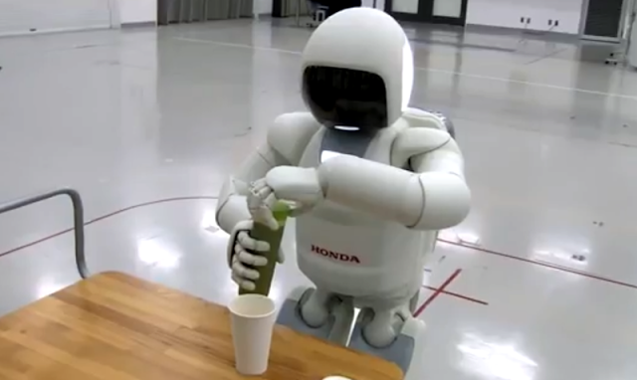

The program details how despite it's many mechanical innovations, Honda's ASIMO robot's most important feature is artificial intelligence. ASIMO's sensors replicate all five senses, helping the robot to better operate in a human world. The strength, sensing and mobility of the robot ASIMO's robot hand is very impressive.
Despite its innovative design and technolgy, ASIMO could not be deployed to Fukishima-Daichi. However Honda has used what it learned from ASIMO's development to create a specially-designed valve-operating robot to help the recovery effort at Fukishima. ASIMO's legs have been re-purposed for the arm of the new robot.
The documentary also features Gill Pratt, head of the DARPA Robotics Challenge (DRC). Pratt talks about how Fukishima demonstrate that humanoid robots are necessary for disaster situations, where numerous obstacles and functions are necessary. According to Pratt, if an emergency-response robot had been available one hour after the start of the earthquake at the Fukishima reactor, the disaster could have been avoided. To navigate in spaces and with equipment designed for humans, a humanoid robot is the best solution.
ATLAS, the default robot being used in the DRC is also shown in detail. The robot, built by Boston Dynamics.
Japanese researchers have been hesitant to enter the DRC, as they feel that the competition really will be used to create military robots. One team, SCHAFT, had to leave their university jobs to enter the competition. Their university did not allow any funding to come from military sources. Honda did not enter the DRC either.

That doesn't mean Honda is not working on advancing humanoid robots. They are building a highly functional next-generation robot capable of the DRC. The robot will be able not just to walk, but crawl and bend to get past the most difficult obstacles.
Read more: http://www.33rdsquare.com/2013/07/robot-revolution-will-machines-surpass.html#ixzz36vhY9VZR
Follow us: @33rdsquare on Twitter | 33rdsquare on Facebook
- Que tipo de texto é esse? De onde ele foi retirado?
_____________________________________________________________________________________________________________________________________________

- A que se refere o título "Robot Revolution : Will Machines surpass humans"? Quando e onde foi produzido?
______________________________________________________________________________________________________________________________________________

- O que a matéria destaca, em relação ao desastre de Fukishima-Daichi, em 2011?
______________________________________________________________________________________________________________________________________________
- Qual é, de acordo com o programa, a característica mais importante do robô Asimo? De que forma isso o ajuda a atuar no mundo humano?
______________________________________________________________________________________________________________________________________________

- O que, de acordo com Gil Pratt, coordenador do Programa DARPA, o desatre de Fukshima demonstra?
______________________________________________________________________________________________________________________________________________

- Por que os pesquisadores japoneses estão hesitantes em aderir ao programa DRC?
______________________________________________________________________________________________________________________________________________

- Retire do texto dez palavras cognatas e dê o seu significado, em português.
___________________________________________________________________________________________________________________________________________________________________________________________________________________________________________________________________________________________________________________________________________________________________

- Retire do texto os termos e/ou expressões equivalentes, em inglês, a:
- robôs humanoides-
- são apresentados-
- sensação de impotência-
- (foi) sentido mundialmente-
- o programa detalha-
- inovações mecânicas-
- apesar do seu design e tecnologia inovadores-
- não poderia ter sido utilizado-

- Retire do texto quatro passagens com o verbo no Simple Present.
____________________________________________________________________________________________________________________________________________________________________________________________________________________________________________________________________________________________

